Functional User Stories

DOD Portal

This document describes the Functional Solution of the system. The document intends to outline the solution by incorporating user stories and screen designs for the project as agreed between the Business Application Owner, all other impacted parties and the IT community.

Version 0.2

# Document Control

The latest published version of this document is located here:

|  |  |  |  |
| --- | --- | --- | --- |
| **Version** | **Date** | **Author** | **Comments** |
|  |  |  |  |
|  |  |  |  |
|  |  |  |  |
|  |  |  |  |
|  |  |  |  |

# Contents

Document Control 2

Contents 3

Executive Summary 4

Background 4

Business Objectives for this Project 4

Scope 4

Definition of Points 4

Supported Platform 4

PLAN 5

Stage 1: Administrating DOD devices 6

1.1 Configuration – User Roles 6

1.2 Configuration – Browse by sites 6

1.3 Configuration – Adding DOD devices 8

1.4 Configuration – Viewing DOD devices 9

1.5 Configuration – Alerts 10

Stage 2: Reports 11

2.1 Reports – view by site 11

2.3 Reports – view by DOD 11

Timeline 13

Appendix 14

A2 Decisions & Implications 14

A3 Definitions, Acronyms and Abbreviations 14

A3 Table of figures 14

A4 References 14

Executive Summary

This section is for an Executive Summary. It may be easier to first complete the Detailed Functional Solution and then complete the summary.

Background

Defrost On-Demand (DOD) devices are peripherals attached to refridgeration assets that are held on store premises. The purposes of these DOD devices is to collect temperature data from those refridgeration devices, which can be used to monitor and diagnose the state of the refridgerators.

Business Objectives for this Project

* Use the source content from the Business Solution Management Report (BSMR for 4QD) or High Level Requirements.& Solution Definition (HLRSD) document
* To create a centralized portal for administration and monitoring of DOD devices.
* To obtain remotely obtain data from DOD devices and process them into meaningful information through reports.

Scope

This document has been created to detail the requirements related to the DOD Portal. This document has also been used to break the project into different stages and estimate each.

Definition of Points

To estimate the development effort of the DOD Portal project, each users story was reviewed (As per scrum methodology – for a maximum period of 2mins) and points were assigned. Points are an Agile concept to express how complex the development team believes a requirement is. Points are used to indicate a scale, 1 indicates a simple task and 13 being the most complex. (Based on the sequencing of Fibonacci) This number was then loosely related to hours. As development continues the estimation of effort will continue to change as requirements are refined and discovered.

Supported Platform

DOD Portal will be developed to support the following versions and above :-

1. Google Chrome 34+
2. Internet Explorer 10+
3. Safari 10+

As responsiveness is a priority for the DOD Portal, the mobile version of the above browsers is also to be supported.

PLAN

|  |  |
| --- | --- |
| Item | Status |
|  |  |
|  |  |
|  |  |
|  |  |
|  |  |
|  |  |
|  |  |
|  |  |
|  |  |
|  |  |
|  |  |
|  |  |
|  |  |
|  |  |
|  |  |
|  |  |

# Stage 1: Administrating DOD devices

**Objective :** Browse stores. Add, view, and edit DOD devices.

**Total Point:**

**Total Hours:**

**Weeks:**

## Configuration – User Roles

(Points: )

Roles:

* Technician
* Customer

Permissions:

* View DOD devices
* Add DOD devices to site
* Edit DOD device
* View reports
* Configure alerts
* Configure parameters

|  |  |  |
| --- | --- | --- |
|  | Technician | Customer |
| View DOD devices | Yes | Yes |
| Add DOD deviceS to site | Yes | No |
| Edit DOD device | Yes | No |
| View reports | Yes | Yes |
| Configure alerts | Yes | No |
| Configure parameters | Yes | No |

## Configuration – Browse by sites

(Points: )

Since DOD devices are installed at sites, the foremost view of the application would be the stores view. Users can navigate through the list of stores.

Figure 1: Store list view (on mobile). Clicking on a store will lead to a site view (see figure 1.2).

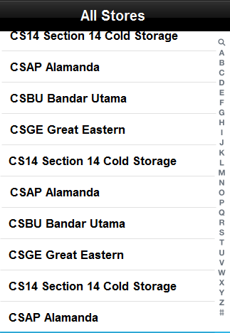

Figure 1.2: Site view

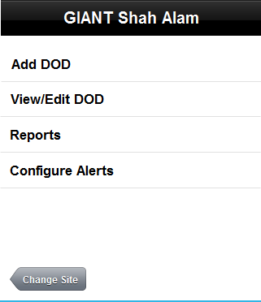

* Add DOD – A technician can add DOD to a site. Clicking on Add DOD leads to the DOD Set-Up screen (Figure 2).
* View/Edit DOD – This option is only visible as “View DODs” for users without write permissions.
* Reports leads to the Reports page.
* Configure Alerts leads to the alerts configuration page.
* Change Site will lead the user back to stores list (Figure 1)

## Configuration – Adding DOD devices

(Points: )

A user of role “Technician” are able to add DOD devices to a site. The form holds the following fields:

* Serial number
* Asset tag
* Location
  + Describes the host device of the DOD device, the host devices will be pulled from a list of assets that is located at this particular site.
* Parameters
  + Can be defined by the user.
  + Supports free text and dropdown menu.

Figure 2: The Add DOD screen, as viewed on a desktop browser

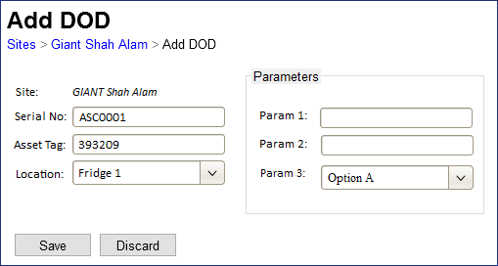

* Page is to provide easy navigation back to the Sites list, or to the Site view via breadcrumbs.
* All fields will be Readonly when the screen is visited through View-mode, i.e: when viewed by a Customer.

## Configuration – Viewing DOD devices

(Points: )

Clicking on View/Edit DOD from the a site’s summary screen will lead to a list of DOD devices located on that premise.

* Grid contains a list of all DOD devices.
* Columns:
  + Location – host device of the DOD device
  + Serial No
  + Asset Tag
  + Alerts – number of alerts that the device currently has. Clicking on the badge leads to the Alerts page.
  + Edit button – will lead to the Add DOD screen with values populated.

Figure 3: The Site > “View/Edit DOD” screen on desktop browser

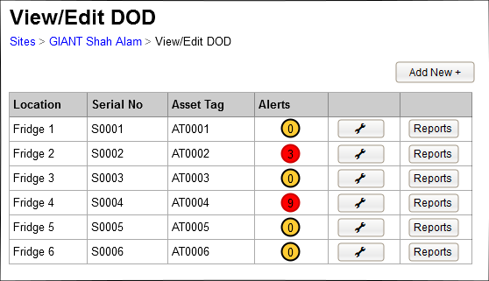

## Configuration – Alerts

(Points: )

The site listens to alerts raised by the DOD devices, and stores the alerts history in the database.

Figure 4: Alerts screen

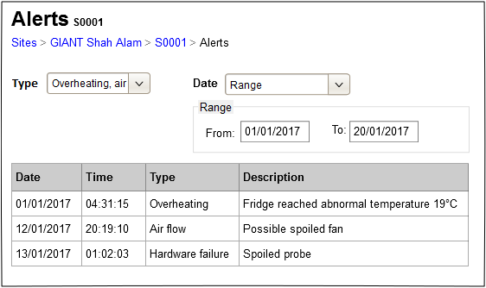

* Type – multi-selection combo box, allows the user to filter the alerts by Alert type
* Date – combo box, with options:
  + Last Hour – shows only alerts that occurred within the last hour
  + Today (default)
  + This week
  + This month
  + Range – chosing this option will enables the From and To field, which allows the user to choose dates from a calendar control

# Stage 2: Reports

**Objective :** Gathering of information from DOD device data

**Total Point:**

**Total Hours:**

**Weeks:**

## 2.1 Reports – view by site

(Points 0)

On desktop sites, clicking on “View” will open the report in a new tab. This way the user can quickly access multiple reports to use for comparisons.

Figure 5: Reports view by site screen – desktop browser

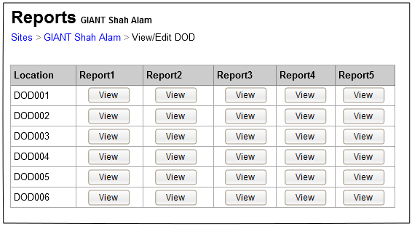

## 2.3 Reports – view by DOD

(Points 0)

User can access the DOD reports screen from the DOD List screen.

This page contains a list of reports that the DOD device produces, and clicking on a button will launch the report in a new tab (desktop browser).

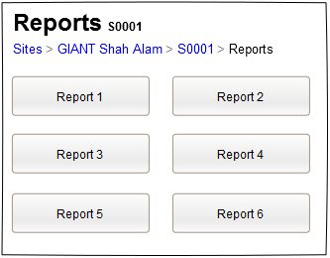

# Timeline

|  |  |  |  |  |  |
| --- | --- | --- | --- | --- | --- |
| Stage | Objective | Total Points | Total Hours | Weeks |  |
| Stage 1 |  |  |  |  |  |
| Stage 2 |  |  |  |  |  |
| Stage 3 |  |  |  |  |  |
| Stage 4 |  |  |  |  |  |
| Stage 5 |  |  |  |  |  |
| Stage 6 |  |  |  |  |  |
| Stage 7 |  |  |  |  |  |
| Stage 8 |  |  |  |  |  |
| Total |  |  |  |  |  |

Use the source content from the BSMR (4QD) or HLRSD .

Appendix

A2 Decisions & Implications

[Insert text]

List the key design decisions and implications that this project faces. For example, a specific design for an interface may prevent

A3 Definitions, Acronyms and Abbreviations

For ease of use, sort this table into Abbreviation & Expanded Term sequence.

Add any terms that you think may be confusing to readers of this document. Some terminology is known and taken for granted within a group, but will be unknown to others outside that group. Consider also terminology that has had changed meaning over time.

|  |  |
| --- | --- |
| **Term** | **Definition** |
|  |  |
|  |  |
|  |  |
|  |  |

A3 Table of figures

**No table of figures entries found.**

A4 References

Business Request Brief<application name>

Feasibility Document<application name>

Business Requirements Document, <application name>

Project Charter, <application name>

Project Management plan, <application name>

Solution Architecture <application name>

Business Solution Management Report (4QD only)

High Level Requirements & Solution Definition (4QD Lite only)

DRP Recovery Strategy, A Guideline for Developing